A close up of a library

Description generated with high confidence

Pulp Novels plc Proposed Contract

An Analysis for Power Printing Ltd.

|  |
| --- |
|  |
|  |
| February 23, 2018  Wright Consultancy  Team 5 |



**Table of Contents**

1. Introduction 3

2. Management Summary 4

3. Background 5

4. Terms of Reference 6

5. Key Findings 7

5.1 The Contract is Infeasible 7

5.2 Negotiations 7

5.2.1 Renegotiate the Contract 7

5.2.2 Renegotiate the Union Agreement 7

5.3 Machinery 7

5.4 Storage 7

5.5 Timeline 8

5.6 Pricing 8

6. Key Recommendations 9

6.1 Factory and Warehouse 9

6.2 Labour 9

6.3 Financing 9

7. Detailed Analysis 10

7.1 Machinery Configuration 10

7.1.1 Assumptions 10

7.1.2 Constraints 10

7.1.3 Methodology 10

7.1.4 Scenario 1 – 2 Shifts 5.5 Days 11

7.1.5 Scenario 2 – 1 Shifts 5 Days 11

7.1.6 Scenario 3 – 2 Shifts, 5 Days (Recommended) 12

7.2 Storage 12

7.2.1 Assumptions 12

7.2.2 Warehouse Options 13

7.2.3 Pallet Analysis 14

7.2.4 Warehouse Design 15

7.3 Timeline 16

7.4 Financial Analysis 17

7.4.1 Assumptions 17

7.4.2 Scenario 1 - 2 Shifts 5.5 Days 17

7.4.3 Scenario 2- 1 Shift 5 Days 18

7.4.4 Scenario 3- 2 Shifts 5 Days (Recommended): 19

7.4.5 Cost per Page 19

7.4.6 Debtors Days 20

7.5 SWOT Analysis 20

8. Conclusion 21

9. Appendices 22

# 1. Introduction

The purpose of the following report is to advise the client, Power Printing Ltd. (PPL), on the contract proposal by Pulp Novels plc. The report outlines the research and analysis done by Team 5, operating on behalf of Wright Consulting, into the logistics, feasibility and profitability of the initial contract offered. The report also extends to examine the possible effects of any renegotiations, either client side (PPL) or to the contract, and those renegotiations which are recommended by Wright Consulting.

All data contained in this report were gathered through either face-to-face interviews or written correspondence with representatives from both the client and from Pulp Novels plc. The representatives from PPL were Mr. M. Power, Ms. P. Power, Mr. L. Typesetter, Mr. T. Booker and Mr. H. Packenham. The representative from Pulp Novels plc was Mr. K. Whitbread.

The information collected was used to model and cost the various scenarios in which the client could accept the contract, and how they would implement any changes.

The factors recognised as crucial were as follows:

* The setup of the factory floor (with both current and new machines).
* The storage of the books.
* The hiring of staff and the future shift structure.

Financial analysis was then conducted using the Net Present Value (NPV) over the duration of the contract. This is the preferred method of the client, as advised by Mr. T. Booker. These calculations were carried out for the most efficient scenarios derived from the aforementioned analysis. Financial performance upon accepting the contract hinged on three primary factors:

* The price the client received per book.
* The weekly quantity ordered by Pulp Novels plc.
* The length of the contract.

The details of this analysis and any key findings are presented in this report. Furthermore, recommendations are made for future action to be taken by the client, PPL, if they accept the contract, in either its current or renegotiated state.

Any assumptions made are clarified in the relevant sections, which may lead to repetition. All calculations and in-depth analysis can be found in the Appendices. Any corresponding sections of the Appendices will be referenced when being discussed in the report.

# 2. Management Summary

The contract proposed by Pulp Novels plc offers Power Printing Ltd. an opportunity to significantly expand current operations. Should PPL produce 35,000 books per week at £9 per book, this would generate an additional £16,380,000 in yearly revenue.

However, in its current state, the contract is not logistically feasible. The Printers’ Union hiring cap of 70 new printing staff would not allow PPL to produce the maximum weekly output of 50,000 books proposed by Pulp Novels plc.

For this contract to be logistically feasible, PPL must negotiate either a lower maximum weekly production (42,315) or a hiring cap of 84 printing staff. Given the financial benefits and greater likelihood of renegotiating the maximum weekly production, the following conclusions are drawn.

The lower weekly output of 42,315 is the maximum output of 18 TP 4000s costing £3,811,500. To accommodate for these machines, magazine presses 3,4,5 and 6 must be relocated to create 2,900 sq. ft. of space. The recommended shift structure is a day shift and an evening shift, Monday to Friday. This configuration, while operating at maximum capacity, has an annual cost of £2,853,670. This includes the wages for 20 apprentices, 42 masters, 8 supervisors and 2 shift leaders.

Books should be stored on plastic pallets in an on-site warehouse of size 22.5m x 12m in the space available adjacent to the factory. An additional two forklifts and two forklift drivers should be acquired to service the warehouse. This warehouse, fully fitted with all required services, would cost £229,377 and take 176 days.

The recommended loan structure for this project is to borrow £309,377 on August 1st, 2018. This loan will finance the construction of the warehouse and the reconfiguration of the factory floor. A second loan of £3,811,500 should be taken out on December 1st, 2018. The purpose of this loan is to finance the purchase of machinery.

As advised by PPL’s Finance Director, Mr. T. Booker, for this project to be accepted the minimum discount rate used in Net Present Value calculations should be 9%. However, given the risks associated with this contract, a rate of 12% is preferred. We recommend extending the contract term to 6 years, which would require PPL to receive a price per book of £9.52. If the duration of the contract cannot be extended, the price received should be £10.08. This allows the contract to remain profitable in the worst-case scenario, where the weekly production is 35,000 books.

The financial analysis contained in this report assumes that the true average length of a book is 220 pages. If the true average increases above 220 pages, PPL will not be able to maintain an annual return of 12% over the duration of the contract. It is vital to maintain a cost per page of 3.2p over the course of the contract. An increase in cost to 3.3p per page would require an extra 22p to be received per book.

# 3. Background

Power Printing Limited is a family-owned printing business established in 1941. The company remained relatively small until about 10 years ago when considerable expansion occurred. During this expansion period the company, which operate a single factory in Manchester, remained for the most part profitable, with the exception of periods of complication involving union agreements. Five years ago, PPL accepted a contract to print the Daily Bugle newspaper. Alongside this they print magazines and occasionally print flyers/leaflets when time permits.

Managing Director Mr. M. Power believes the success of the company has largely been attributed to the fact that they have not overreached themselves. Having been approached by Pulp Novels plc with a contract proposal in August 2017, professional advice was sought. On the 22nd of September, Mr. M. Power contacted Gerry Wright of Wright Consulting seeking a recommendation regarding the feasibility and profitability of the contract offered. Our team were assigned to the project to analyse the proposed contract under certain terms of reference. Pulp Novels plc require PPL to print, bind and temporarily store between 35,000-50,000 books a week as the company look to launch a new set of novels for the European market.

# 4. Terms of Reference

Mr. M. Power; Managing Director of Power Printing Limited (PPL) has requested advice on whether or not they should accept a contract offer which has been made to them by Pulp Novels plc.

Throughout our analysis of the proposed contract, we were clearly instructed by PPL to refrain from engaging in any form of negotiation on their behalf. We have been employed to establish whether, in terms of logistics, the contract is feasible and to assess the return which could be generated as a result of accepting the contract.

Should we conclude that it is not beneficial for PPL to accept the proposed contract, we would provide suggestions as to how certain term(s) of the contract could be altered to make the venture worthwhile for PPL.

# 5. Key Findings

This section outlines the key findings that support our recommendations. All figures and calculations have been taken from Section 7, *Detailed Analysis*.

5.1 The Contract is Infeasible

The contract offered by Pulp Novels plc to PPL, in its current form, is logistically infeasible. PPL would be unable to produce the required maximum of 50,000 books per week under current restrictions. In accordance with the Union Agreement between the Printers’ Union and PPL, a maximum of 70 new printers may be hired. This remains effective until renegotiation of the agreement in 2022. In combination with the current output rate of available machinery, it is not possible to achieve the desired output as requested by Pulp Novels plc. In line with current union restrictions and machinery available, the maximum output PPL can reach is 42,315 books per week.

5.2 Negotiations

There are two solutions available to PPL that would deem the contract feasible.

5.2.1 Renegotiate the Contract

* The first solution is to renegotiate the contract to agree on a lower weekly maximum. As mentioned above, the maximum output PPL can reach is 42,315 books per week.

5.2.2 Renegotiate the Union Agreement

* The second solution is renegotiating the Union Agreement. PPL would require 84 new staff to satisfy the level of output as per the proposed contract.

5.3 Machinery

Under the current constraints, it is impossible to produce the proposed weekly maximum of 50,000 books. It was also found to be infeasible to operate on a single shift basis, due to low output and high costs. The most cost-efficient shift structure is to operate a day and evening shift five days a week.

The maximum output that can be produced under current constraints is 42,315 books per week which uses TP 4000 machines only. PPL should purchase 18 of these machines, with all 18 operating during the day shift and 17 operating during the evening shift. This purchase would cost £3,811,500 and does not require the Goss press to be moved. Moving the Goss press was found to impose unnecessary costs as additional space was not required.

5.4 Storage

Building an on-site storage facility is more cost-effective. Over the course of a three-year contract, the cost of renting a 50m x 25m warehouse, located 1.5 miles from the factory is £522,295 more expensive than an on-site alternative.

A warehouse of 22.5m x 12m is suitable for this project. This allows for four rows of three-storey racking of length 18.5m with a maximum capacity of 240,244 books.

5.5 Timeline

There are many tasks to be completed to reconfigure the factory and construct a warehouse. These tasks must be carried out in a certain chronological order. It was found that the shortest possible time the factory reconfiguration and training of new staff could be completed is 159 days. Likewise, a longer period of 176 days would be required to construct and prepare the warehouse.

By commencing work on August 1st, 2018, the factory should be ready by January 7th, 2019. The warehouse should be constructed and fully fitted by January 24th. This would allow sufficient time for PPL to begin printing for the Frankfurt book fair in February 2019. This also accommodates for any delays or issues which may arise during construction or reconfiguration.

5.6 Pricing

The proposed price per book of £9 should not be accepted. The prices that provide a positive Net Present Value while discounting future cashflows at 12% are as follows:

|  |  |
| --- | --- |
|  | Price Per Book |
| 3 Years | £10.07 |
| 4 Years | £9.79 |
| 5 Years | £9.64 |
| 6 Years | £9.51 |

Figure 1: Required Price per Book

These figures are based on a worst-case scenario where production is at a constant minimum of 35,000 books per week, with an average book length of 220 pages.

The prices above are sensitive to change in both the cost per page and average number of pages. An increase in the average length of the books by 1 page would require a 4p increase in the price received per book. An increase in the cost per page from 3.2p to 3.3p would require an increase of approximately 23p per book.

6. Key Recommendations

The contract proposed by Pulp Novels plc should not be accepted in its current state. It is logistically infeasible and does not offer an acceptable rate of return. Below we have outlined a number of recommendations which we believe will solve these issues.

6.1 Factory and Warehouse

* Magazine presses 3, 4, 5 and 6 should be moved to generate 2,900 sq. ft. to accommodate new machinery.
* We recommend purchasing 18 TP 4000s from Superior Print Machines.
* The maximum weekly order quantity cannot exceed 42,315.
* An on-site warehouse of size 22.5m x 12m x 5m should be constructed.
* PPL should purchase 2 additional forklifts for this project.
* Construction and reconfiguration should begin on August 1st, 2018.

6.2 Labour

* Power Printing Ltd. should hire 20 apprentices, 42 masters, 8 supervisors, 2 shift leaders and 2 forklift drivers.
* We recommend a shift structure of two shifts per day, five days a week.

6.3 Financing

* The contract duration should be extended to 6 years.
* The price received per book from Pulp Novels plc should increase from £9 to £9.52. If PPL are unable to secure a longer contract duration, the three-year price should increase to £10.08.
* PPL should ensure the cost per page remains constant at 3.2p for the duration of the contract.
* The recommended loan structure includes one loan of £309,377 extracted on August 1st, 2019 to cover factory and warehouse costs. A second loan should be taken out on December 1st, 2019 to cover costs associated with the purchase of machinery amounting to £3,811,500. These loans will be paid off over the duration of contract.

# 7. Detailed Analysis

7.1 Machinery Configuration

7.1.1 Assumptions

#### 7.1.1.1 Machinery

* The TP 4000 has an hourly output of 31 books of standard size, or 220 pages.
* Machine purchases are subject to V.A.T. of 21%.
* Book presses are running only for the hours they are used, and this depends on shift structure and demand for the given week.

#### 7.1.1.2 Labour

* Printing staff can work 39 hours a week, and no more.
* Printing staff are working efficiently during their 39 hours of work.
* It is assumed that printing staff are paid solely for the hours they work – and the hours they work depends on predicted sales levels for that week.
* During the day shift, apprentices are paid at a standard rate of £10 p/hr, masters £16 p/hr and supervisors £20 p/hr. Evening shift staff are paid time and a half, and night shift staff are paid double time. There is no special weekend rate.
* Shift leaders are paid an annual salary of £32,000.
* Maintenance is carried out on Saturday, and as a result there can be no shift. There are large overhead costs associated with working on Sunday, and thus it is undesirable.

#### 7.1.1.3 Factory

* Moving the Goss Press generates 4,500 sq. ft. of space, while leaving it where it is and relocating the magazine presses generates 2,900 sq. ft. of space.

### 7.1.2 Constraints

Considering the above assumptions, the constraints related to this project are:

* The Union agreement stipulates that only 70 new printing staff can be hired. Supervisors are printing staff and are included in this cap, while shift leaders are not.
* A printer can work no more than 39 hours per week.
* The constraint on space is either 2,900 sq. ft. or 4,500 sq. ft., depending on whether the Goss Press is moved.
* Night shifts (12:00 – 08:00) and weekend shifts are not preferred.
* The preliminary contract offer dictates that a minimum of 35,000 books be produced, and a maximum of 50,000.

### 7.1.3 Methodology

An optimisation algorithm, or a solver, was developed to decide how many of each machine should be purchased. The solver focused on maximising the possible output (measured in books per week) while satisfying the above constraints. Quotes were provided for three different book presses, all with varying capabilities. A brief breakdown of these machines can be seen in Appendix A.

The primary constraint was found to be the Union-imposed hiring cap. It is= impossible to produce 50,000 books a week with 70 printers. The following table illustrates the necessary conditions to produce a weekly output of 50,000 books. The TP 4000 is the most efficient press in terms of output, with each man printing 15.5 books per hour. This is relevant as no more than 70 workers per hour can be hired to fulfil the contract.

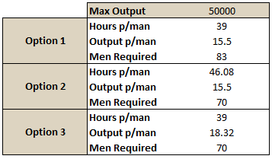

Figure 2: Maximum Output 50,000

The three options, outlined in Figure 2, that produce 50,000 books are hiring more printing staff, having 70 printing staff working longer hours, or sourcing a more efficient machine (e.g. the TP 5000). Given that there are no machines capable of producing the necessary output, and that working over 46 hours a week would be risky and unsafe, the most realistic approach would be to alter the hiring cap.

Three scenarios were then developed. The details of all three can be seen in Appendix B. Scenario 1 satisfies all client-side constraints (Union and labour), but would require renegotiation of the contract. Scenario 2 satisfies all client-side constraints as above, and satisfies PPL’s preferences, but does not satisfy the terms of the contract. Scenario 3 satisfies the terms of the contract (it can produce 50,000 books a week), but requires renegotiation of the Union agreement, and deviates from some of PPL’s preferences.

### 7.1.4 Scenario 1 – 2 Shifts 5.5 Days

This scenario would require renegotiation of the Union hiring cap to allow for 84 new printing staff. This allows an output of 50,000 to be reached. The extra staff would be needed from September 2020 once weekly output exceeds 42,315. This scenario can produce 50,526 books per week, which would be beneficial in case of breakdown or inefficiency. This scenario operates a daytime shift and an evening shift from Monday to Friday inclusive, and a single day shift on either Saturday or Sunday.

The Goss press would not need to be moved in this scenario, as 19 TP 4000’s needs 2,736 sq. ft. This is favourable as it eliminates a sizeable loss of revenue from outsourcing, as well as factory reconfiguration costs. Details of costs for all scenarios are also found in Appendix B.

### 7.1.5 Scenario 2 – 1 Shifts 5 Days

PPL indicated that it is preferable to operate only a single shift for the duration of this contract, with no printing taking place on Saturday or Sunday. This scenario satisfies those preferences, but requires the moving of the Goss press, which comes at a substantial cost (loss of revenue through outsourcing and reconfiguration).

This scenario has a maximum weekly output of only 39,507 books. This would satisfy sales projections until March 2020, but does not satisfy the contract. Weekly revenue from the contract would be capped at 39,507 x £9 = £355,563.

### 7.1.6 Scenario 3 – 2 Shifts, 5 Days (Recommended)

This scenario operates a daytime shift and an evening shift from Monday to Friday. Evening shifts are required to obtain maximum efficiency (allocating all 70 new staff to TP 4000s). This scenario does not feature weekend shifts, as desired. This requires 18 TP 4000s, with only 17 being operational during the evening shift. This model is recommended as it has a substantially lower total cost over all possible contract durations, while producing more books. It can produce 2,808 more books than the single shift model, which amounts to an additional £25,272 in weekly revenue at £9 per book.

This configuration would fall 89 books short of satisfying the September 2020 predictions, but would otherwise satisfy the projections until March 2021. Labour is the binding constraint, so more staff would be needed to increase this output.

## 7.2 Storage

### 7.2.1 Assumptions

#### 7.2.1.1 Warehouse

* The price per square foot of £60 for a warehouse including racking must be applied to the whole warehouse. This warehouse is then fit for purpose.
* A forklift requires a corridor of width of 4m to operate effectively.
* Storage is required for 4 weeks of production, which amounts to a maximum of approximately 208,000 books based on the sales projections.
* The site available for construction measures 30 x 16 yards.

#### 7.2.1.2 Books

* The weight sample provided by Mr. K. Whitbread is indicative of the entire QNF series.
* The maximum weight of a book was calculated to be 0.776 kilograms by bootstrapping the weights of the sample of 13 books (Appendix C). This figure was used for pallet capacity calculations.
* As advised by Mr. K. Whitbread, the dimensions of a typical QNF book are 20cm x 15cm x 1.5cm. The depth of 1.5cm is normally distributed with a standard deviation of 0.2mm.
* It is assumed that 300 new titles will be required each year. For ease of calculation, this is assumed to be 6 titles per week, on average, in each language. As a result, printing in 4 languages would require 24 titles, and 6 languages would require 36 titles.
* It is assumed that the sales projections provided to Power Printing Ltd. by Pulp Novels plc are an accurate and honest representation of future sales, up to and including the quarter ending March 2025.

#### 7.2.1.3 Pallets

* Wooden pallets cost £2.50, have a weight limit of 1,500kg and a life expectancy of 18 months.
* Plastic pallets cost £25, have a weight limit of 2,000kg and will last indefinitely.
* Both pallet types have dimensions of 1m x 1m x 0.15m (6 inches).
* Pallets will be returned upon collection of the next consignment.
* Each pallet must consist solely of books of the same title written in the same language.

### 7.2.2 Warehouse Options

As per the contract, books are required to be stored temporarily by PPL until their collection by Pulp Novels plc. There are two storage options available to PPL.

* A warehouse could be constructed in the landscaped area beside the factory, which measures 30 x 16 yards, or 27.43m x 14.63m.
* A warehouse near the factory could be rented. The most suitable option identified is a warehouse of 50m x 25m that is approximately 1.5 miles from the factory.

The construction of an onsite warehouse is cheaper across all contract durations. It was also indicated as PPL’s preferred option. It would increase the efficiency of operations as books would not need to be transported to an external site.

The table below illustrates the total cost of renting and building over a number of possible contract durations. The full breakdown of costs is outlined in Appendix D. The field ‘Other Costs’ in both tables includes the cost of dehumidification, paving and shrink-wrapping. Insurance costs are excluded as they are assumed to be constant across both options, and thus are negligible.

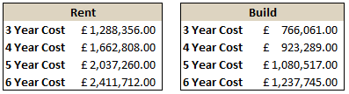

Figure 3: Build/Rent Costs

The warehouse used for these calculations is 18.5m x 12m warehouse as shown in Appendix E.

### 7.2.3 Pallet Analysis

#### 7.2.3.1 Pallet Design

The most efficient pallet orientation accommodates 33 books per pallet (see Appendix F). This setup allows for 96% utilisation of the available pallet surface area. Figure 4 outlines the capacity of both pallet types. Plastic pallets are capable of holding 2,574 books, while wooden pallets can hold 1,914 books.

Figure 4: Pallet Capacity

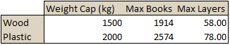

#### 7.2.3.2 Racking

PPL must be prepared for the maximum quarterly output of each language over the course of the contract. While this event is unlikely, it is deemed necessary to ensure that PPL can handle this level of demand. This amounts to a quarterly total of 627,750 books over three years, and 780,750 books over six years, in accordance with the sales projections. (see Appendix G)

Allowing for 300 distinct titles, Appendix G outlines the number of pallets required to hold all books, organised by language. The three-year projections would require a maximum of 120 pallets per month, regardless of pallet type selected. However, six-year projections would require either 192 wooden pallets or 168 plastic pallets. The difference in figures arises from the greater capacity of the plastic pallets. These figures are calculated on a worst-case basis whereby books are collected monthly by Pulp Novels plc. A greater collection frequency would reduce the number of pallets required significantly.

Figure 5 outlines the number of pallets the warehouse can accommodate. This is largely dependent on the space between pallets. A gap of 0.5m between pallets would be adequate for both pallet type should a three-year contract be accepted. PPL would be required to reduce this distance should the contract be increased to six years without an increase in collection frequency.

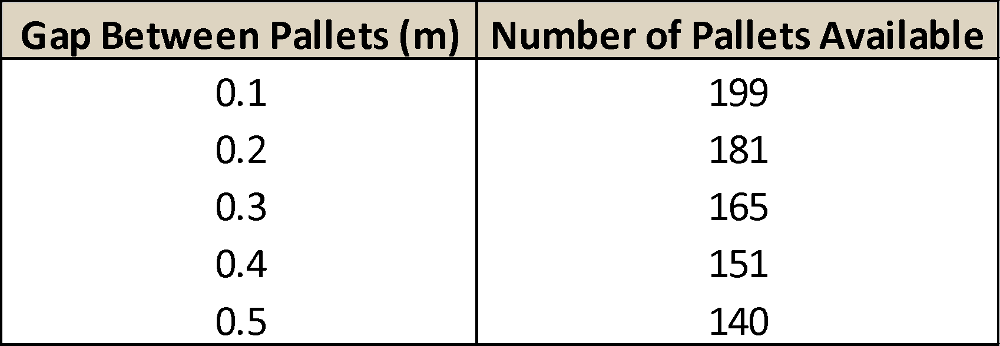

Figure 5: Distance between Pallets

#### 7.2.3.3 Cost Analysis

Appendix H outlines the costs associated with stocking the warehouse with pallets. This analysis allows for full restocking of pallets following collection by Pulp Novels plc. The 18-month lifespan of wooden pallets greatly increases the number of pallets required over time.

Although the cost of plastic pallets is greater than the cost of wooden pallets over both the three-year and six-year projections, the cost is relatively insignificant given the magnitude of the project as a whole. Therefore, it is advised to use plastic pallets, as they will provide superior quality and longevity.

### 7.2.4 Warehouse Design

The warehouse dimensions, based on the chosen space between pallets outlined above, is 12m x 22.5m. This includes four rows of racking of length 18.5m. This is the necessary size to store a month’s worth of maximum production (208,000 books). There are three storeys of racking, with a gap of 15cm between each layer, and an assumed shelf thickness of 15cm. This allows a forklift with a reach of 3.5m to access the highest level. As a result, the recommended height of the warehouse is 5m (Appendix I).

Two forklifts are to be purchased and two full-time forklift drivers hired. Purchasing more than two forklifts would be excessive. During collection, one forklift can be loading onto the truck while the other collects a pallet. If the collection process is deemed too slow, an additional forklift and forklift driver should be acquired.

## 7.3 Timeline

The factory floor must be reconfigured to create space for the new machinery while also not affecting PPL’s current operations (Appendix J). At present the factory holds the Goss Press and six magazine presses. By moving the six magazine presses toward the west wall and the Goss Press closer to the offices, 4500 sq. ft. can be created. By moving only magazine presses 3,4,5,6 2900 sq. ft. can be created. Despite the increased floor space, there would be considerable costs incurred as a result of moving the Goss Press. Should it be moved, production would need to be outsourced to Midland Printing for a period of either four or six months. As informed by Mr. M. Power, outsourcing for a period of four months would result in costs of £4.1m, while outsourcing for six months would incur costs of £6m. As well as outsourcing, moving the Goss Press requires that the roof be altered and soundproofing be installed. The extra cost of this is thought to be in the region of £320,000.

Given the relationship between the factory reconfiguration and the building of the warehouse, an event logic list has been created (Appendix K). This provides a greater understanding of how both factory and warehouse events are synchronised over the period. The event logic can be viewed graphically in Appendix L. Based on the event logic, the accumulated number of days to prepare for the contract is 176. Should the Goss Press be moved, this figure would increase to 218 days.

7.4 Financial Analysis

7.4.1 Assumptions

7.4.1.1 Books

* Books produced have a true average of 220 pages.

7.4.1.2 Machinery and Labour

* Wages and machine running costs are dependent on the number of books produced. These costs can be expressed as a proportion of costs operating at maximum capacity.

7.4.1.3 Net Present Value

* The Net Present Value of future cash flows from this project should be positive when discounted at 12% for the project to be considered worthwhile.

7.4.1.4 Loan

* A loan with a fixed interest rate of 7% can be obtained.
* The loan will be paid in full by contract termination.
* The bank overdraft cannot exceed £1,000,000.

7.4.1.5 Pulp Novels plc

* Having examined accounts provided by Pulp Novels plc, it was established PPL would receive payments one month after collection.
* The sales projections provided by Pulp Novels plc are an honest and accurate prediction of future sales.

7.4.2 Scenario 1 - 2 Shifts 5.5 Days

Figure 6 displays the costs associated with scenario 1:

|  |  |
| --- | --- |
| **Machinery** | £4,023,250 |
| **Factory Reconfiguration** | £80,000 |
| **Warehouse Construction** | £229,377 |

Figure 6: Scenario 1

Considering these costs and relevant timelines, the following loan capital schedule is recommended:

|  |  |  |
| --- | --- | --- |
| **Purpose** | **Date** | **Loan** |
| **Factory Reconfiguration and Warehouse Construction** | 01/08/2018 | £309,377 |
| **Machinery, Forklift, Dehumidifier and Hardware Purchases** | 01/12/2018 | £4,023,250 |

Figure 7: Loan Structure – Scenario 1

7.4.2.1 Price Analysis

The recommended price per book is determined primarily by the length of the contract. Requesting a longer contract term would reduce the required price per book. Figure 8 outlines the necessary price to reach positive NPV at a discount rate of 12%. This is based on worst case demand as per contract terms and projected demand as informed by Pulp Novels plc.

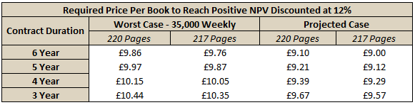

Figure 8: Required Price per Book

Based on the sales predictions provided by Pulp Novels plc and information regarding translation effects from Ms. P. Glott, Multilingua Ltd., it has been estimated that the average length of a book produced is 217 pages (Appendix M).

The maximum number of books PPL can produce is 50,536. In cases where the weekly projections exceed this maximum, the projection for that week is replaced by 50,536.

Should a 3-year term be accepted, a price per book of £10.44 would be required to obtain a positive NPV at 12%. Similarly, a minimum price of £9.86 per book is required for a 6-year contract. However, a price of £9.76 should be sufficient if the average book length was to decrease as anticipated. This is seen in Figure 8.

7.4.3 Scenario 2- 1 Shift 5 Days

The following costs are associated with scenario 2:

|  |  |
| --- | --- |
| **Machinery** | £6,467,450 |
| **Factory Reconfiguration** | £4,433,333 |
| **Warehouse Construction** | £229,377 |

Figure 9: Scenario 2

The timeline for Scenario 2 exceeds that of both Scenario 1 and Scenario 3, leading to the following loan schedule implementation:

|  |  |  |
| --- | --- | --- |
| **Purpose** | **Date** | **Loan** |
| **Factory Reconfiguration and Warehouse Construction** | 01/06/2018 | £4,662,710 |
| **Machinery, Forklift, Dehumidifier and Hardware Purchases** | 01/12/2018 | £6,467,450 |

Figure 10: Loan Structure – Scenario 1

The large costs associated with moving the Goss Press (requiring outsourcing and loss of revenue) and the purchase of machinery required forces PPL into a bank overdraft. This overdraft will exceed £1,000,000 by January 2019. Therefore, this scenario has been deemed infeasible.

7.4.4 Scenario 3- 2 Shifts 5 Days (Recommended):

The following costs are associated with Scenario 3:

|  |  |
| --- | --- |
| **Machinery** | £3,811,500 |
| **Factory Reconfiguration** | £80,000 |
| **Warehouse Construction** | £229,377 |

Figure 11: Scenario 3

Considering these costs and relevant timelines, the following loan capital schedule is recommended:

|  |  |  |
| --- | --- | --- |
| **Purpose** | **Date** | **Loan** |
| **Factory Reconfiguration and Warehouse Construction** | 01/08/2018 | £309,377 |
| **Machinery, Forklift, Dehumidifier and Hardware Purchases** | 01/12/2018 | £3,811,500 |

Figure 12: Loan Structure – Scenario 3

7.4.4.1 Price Analysis

In the worst-case, PPL would be required to print a constant 35,000 books over the duration of the contract. Outlined in Figure 13 is the price PPL must receive to have a positive NPV at a discount rate of 12%. A longer contract term will reduce the price per book required to maintain a return of 12%.

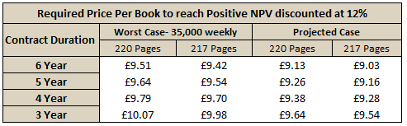

Figure 13: Required Price per Book

The maximum number of books PPL can produce is 42,315. In cases where the weekly projections exceed this maximum, the projection for that week is replaced by 42,315.

Should a 3-year term be accepted, a price per book of £10.07 would be required to obtain a positive NPV at 12%. Similarly, a minimum price of £9.51 per book is required for a 6-year contract (see Appendix N for a graphical representation). However, a price of £9.42 should be sufficient if the average book length was to decrease as anticipated. This can be seen in Figure 13.

7.4.5 Cost per Page

The expected cost per page as provided by Ms. P. Power was 3.2p. The prices given above are sensitive to an increase in the cost per page. For example, if the cost per page was to increase to 3.3p, the cost per book would have to increase by £0.22 to maintain a return of 12% in Scenario 3 (recommended) over three years. It is vital that PPL secure a cost per page of 3.2p over the duration of the contract as any increase in cost per page would pose risks to financial security.

7.4.6 Debtors Days

It became apparent that by implementing a discount scheme, debtors’ days could be reduced. In an attempt to free up additional funds, five possible courses of action were suggested by Ms. P. Power.

Figure 14 illustrates the net cash made available by each course of action consider. The most effective option, as seen in Figure 14, is to reduce debtor’s days to 90 and suffer the loss of 2% of all credit sales.

The net cash made available through this action could be used to eliminate the need for an overdraft or finance any other aspect of the project.

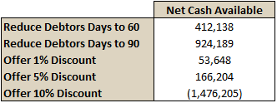

Figure 14: Debtors Days Reductions

7.5 SWOT Analysis

The following table outlines the relevant internal and external factors using the SWOT (Strengths, Weaknesses, Opportunities and Threats) framework.

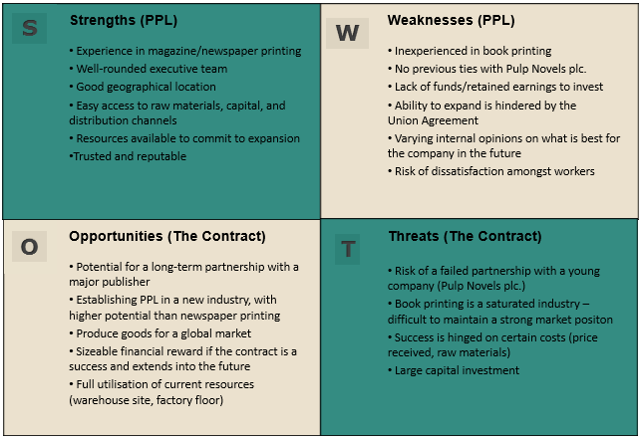

Figure 15: SWOT Analysis

8. Conclusion

The current contract proposal should not be accepted. There are a number of factors that undermine the strength of the contract. However, given the rapid growth of Pulp Novels plc and their prominence in the market, an opportunity such as this should not be overlooked.

It is evident that several adjustments to the contract would need to be made to ensure it is a worthwhile venture for Power Printing Ltd. These pertain to the maximum weekly output, the collection frequency and the price received per book. Should these issues be addressed as has been advised, the contract should be accepted.

Team 5

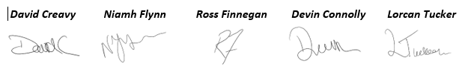

9. Appendices

Appendix A: Machinery Breakdown

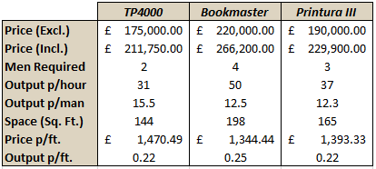

Appendix B: Shift/Machinery Scenarios

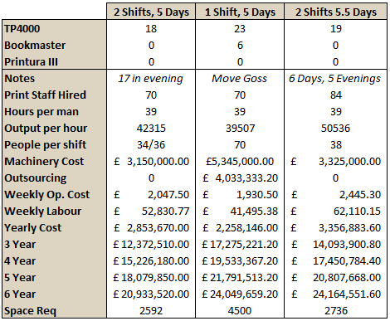

Appendix C: Bootstrap Sample

Bootstrapping is a statistical technique which generates a larger sample (by random sampling with replacement) from a given sample. 700 samples of 13 weights were generated from the original sample provided by Mr. K. Whitbread. Below is an example of a bootstrapped sample.

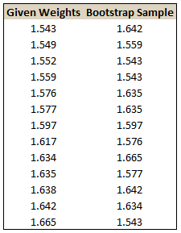

Appendix D: Rent and Build Cost Comparison

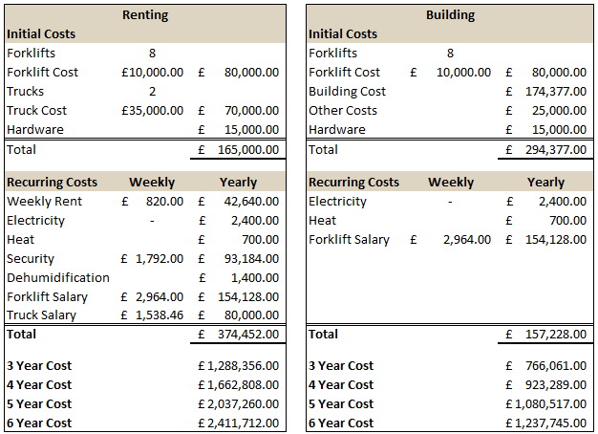

Appendix E: Warehouse Plan

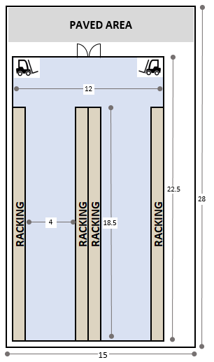

Appendix F: Pallet Design

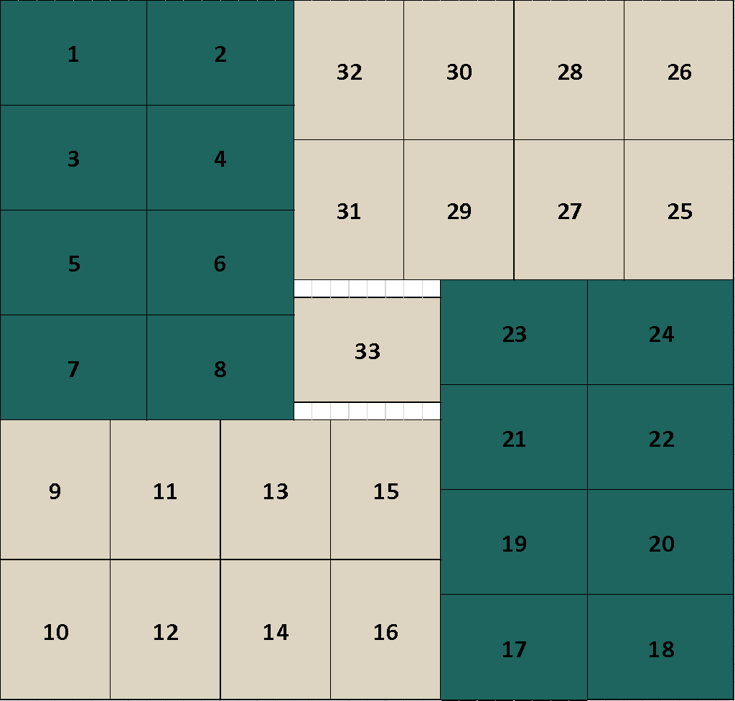

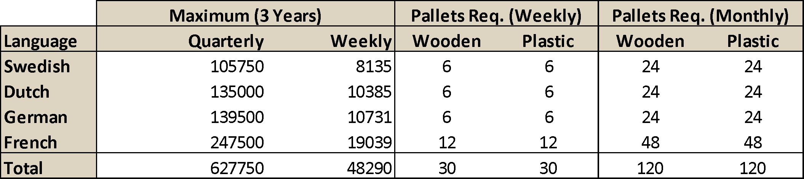Appendix G: Pallet Requirements

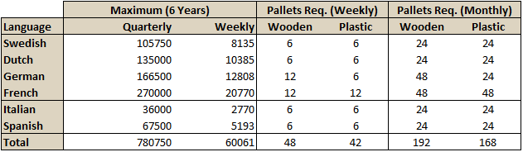

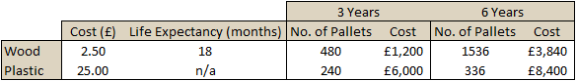Appendix H: Pallet Cost Analysis

Appendix I: Warehouse Height

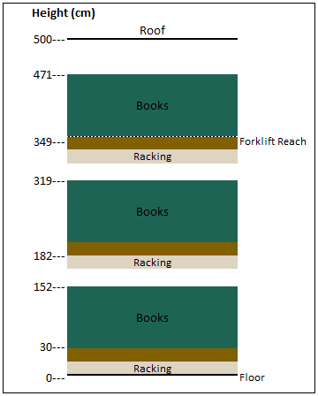

Appendix J: Factory Reconfiguration

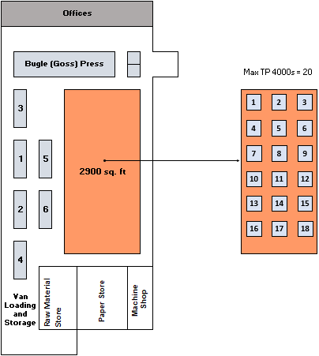

Appendix K: Event Logic

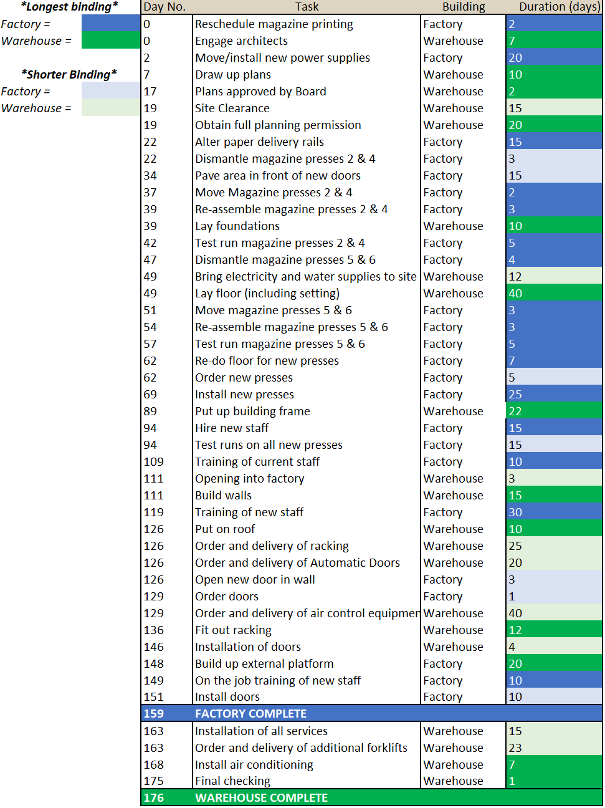

Appendix L: Timeline

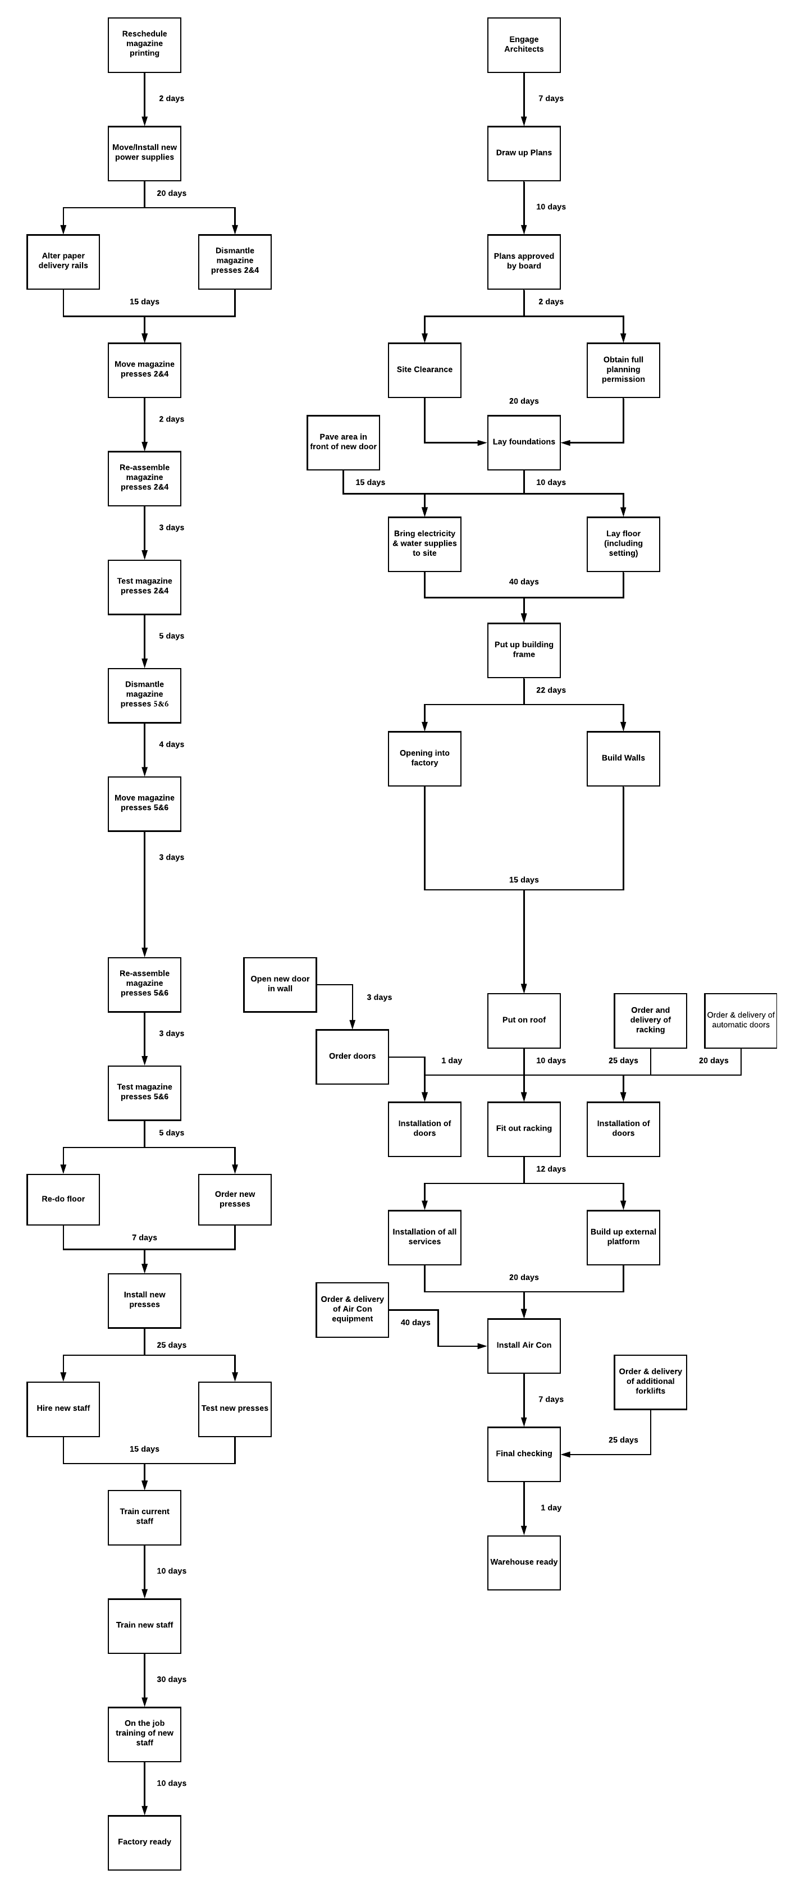



Appendix M: Translation Effect

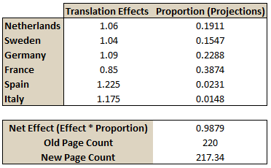

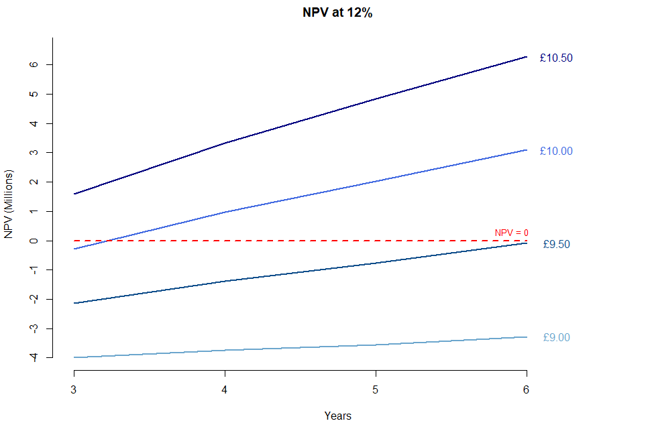Appendix N: Required Price per Book (Discount Rate = 12%)